WholeCart 1.0: Bug Report
Defects found so far, each with steps to reproduce, expected and actual result, severity and a screenshot.
Tester: Sonam Tripathi
Application: http://13.200.185.1/c/sonam-c06faf/
Test date: 10 October 2026
Browsers: Chrome (incognito) and Edge (InPrivate), desktop
Accounts used: buyer1 (Spice Route Kitchen), buyer2 (Café Dosa Corner), seller2 (FreshFarm Foods)
References: Functional design document (BR-xx rules) and release notes (CR-xx changes, which override the design document).
Severity scale: High means money, tax or data is wrong, or a business rule is broken. Medium means required information or behaviour is missing but there is a workaround. Low means cosmetic or minor.

Summary
- DEF-01 – Checkout shows any text taken from the URL as an error message – Low
- DEF-02 – Seller Orders: Actions column rows misaligned – Low
- DEF-03 – Invoice has no Supply type and no Place of supply (CR-09) – High
- DEF-04 – Invoice does not show the seller's GSTIN – High
- DEF-05 – Delivery fee missing as a line on the invoice – Medium
- DEF-06 – Invoice total is almost invisible – Low
- DEF-07 – Refund requests exceed the quantity ordered, and both are approved – High
- DEF-08 – Monthly statement includes a cancelled order – High
- DEF-09 – Minimum order is not enforced for the second seller in a mixed cart (CR-07) – High
- DEF-10 – Logistics export has no rows although orders are waiting for delivery – High
Totals: 6 High, 1 Medium, 3 Low.

DEF-01: Checkout shows any text taken from the URL as an error message
Severity: Low
User and page: buyer1, Checkout
Steps to reproduce:
- Log in as buyer1, add a FreshFarm Foods product to the cart and open Checkout.
- In the address bar, open: http://13.200.185.1/c/sonam-c06faf/checkout?date=2026-10-11&error=Test%20message
Expected result: Error banners appear only when the system itself finds a problem (for example the minimum order message). Text typed into the URL is ignored.
Actual result: A red banner shows “Test message”, the text from the URL.
Impact: A link can be crafted to show a buyer a fake or misleading message inside the real WholeCart page.
Note: The cart page (?msg=Added to cart) and the order page (?msg=Request sent to the seller) use the same pattern and are probably affected too. Not yet tested.
Screenshot:
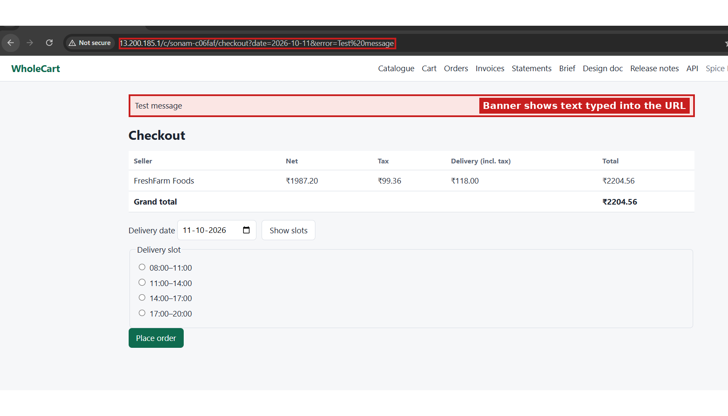
Checkout page showing “Test message” from the URL (red boxes mark the URL and the banner).

DEF-02: Seller Orders: Actions column rows misaligned
Severity: Low
User and page: seller2, Orders (/seller/orders)
Steps to reproduce:
- Log in as seller2.
- Open Orders.
Expected result: Each row’s Actions cell lines up with the other cells of the same row.
Actual result: The row borders of the Actions column are offset from the other columns, so the table looks shifted.
Screenshot:
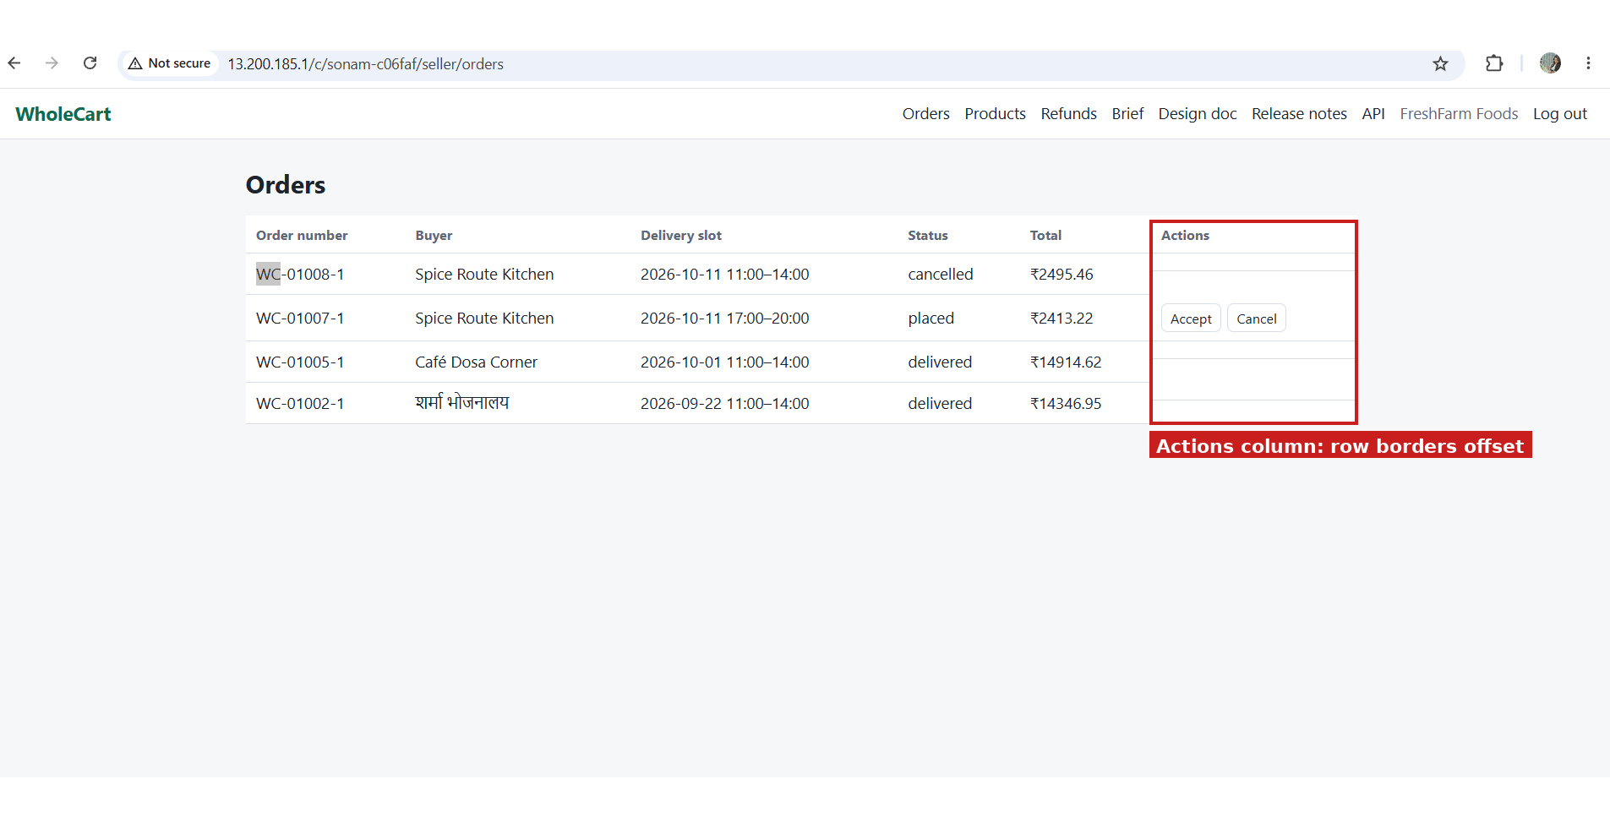
Seller Orders page (red box marks the Actions column).

DEF-03: Invoice has no Supply type and no Place of supply (CR-09)
Severity: High
User and page: buyer1, Invoices, INV-00007 (order WC-01007-1)
Steps to reproduce:
- As buyer1, add 11 cases of Royal Basmati Rice (SKU-0011, FreshFarm Foods) and place the order (order WC-01007-1, total ₹2,413.22).
- As seller2, open Orders and click Accept, then Ship, then Deliver.
- As buyer1, open Invoices and open INV-00007.
Expected result: The invoice shows “Supply type: B2B” and “Place of supply” (state name and code taken from the buyer’s GSTIN, here Goa (30)). Release note CR-09 says invoices without these two lines are not valid for input tax credit.
Actual result: Neither line appears anywhere on the invoice.
Screenshot:
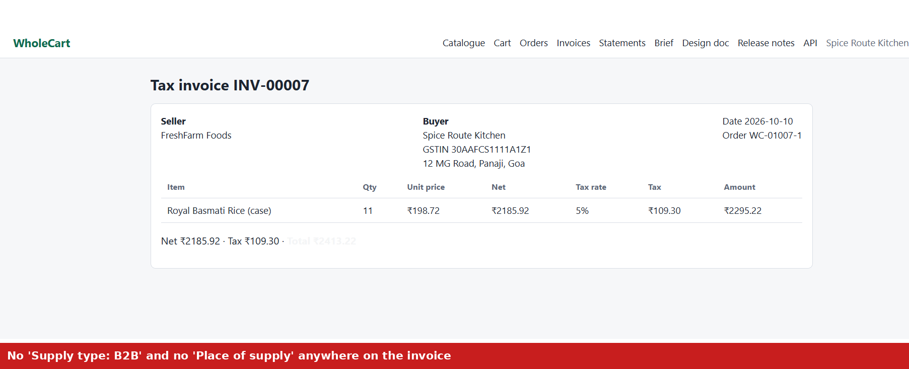
Invoice INV-00007 with no Supply type and no Place of supply.

DEF-04: Invoice does not show the seller’s GSTIN
Severity: High
User and page: buyer1, Invoices, INV-00007 (order WC-01007-1)
Steps to reproduce:
- As buyer1, add 11 cases of Royal Basmati Rice (SKU-0011, FreshFarm Foods) and place the order (order WC-01007-1, total ₹2,413.22).
- As seller2, open Orders and click Accept, then Ship, then Deliver.
- As buyer1, open Invoices and open INV-00007.
Expected result: The seller’s name and GSTIN appear top left (BR-19, design document section 5.4).
Actual result: Only “FreshFarm Foods” is shown, with no GSTIN. The buyer’s GSTIN (30AAFCS1111A1Z1) is shown correctly.
Screenshot:
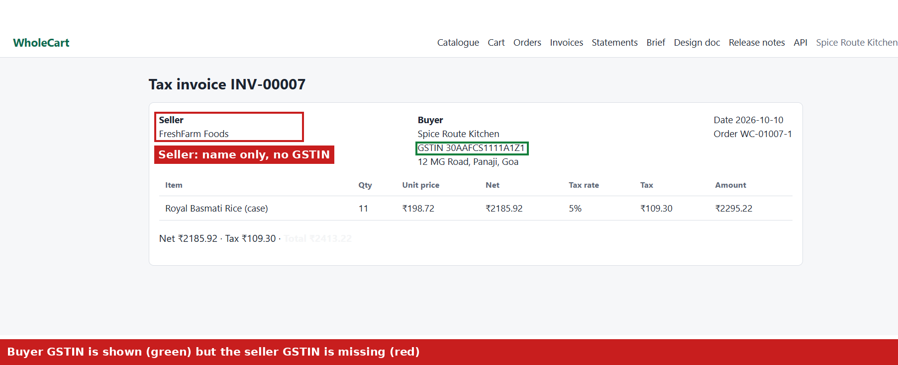
Invoice INV-00007: seller block (red) has no GSTIN, buyer GSTIN (green) is shown.

DEF-05: Delivery fee missing as a line on the invoice
Severity: Medium
User and page: buyer1, Invoices, INV-00007 (order WC-01007-1)
Steps to reproduce:
- As buyer1, add 11 cases of Royal Basmati Rice (SKU-0011, FreshFarm Foods) and place the order (order WC-01007-1, total ₹2,413.22).
- As seller2, open Orders and click Accept, then Ship, then Deliver.
- As buyer1, open Invoices and open INV-00007.
Expected result: The delivery fee appears as its own line (₹100.00 + 18% tax = ₹118.00), and the total equals the order total (BR-08, BR-19).
Actual result: The only line is Royal Basmati Rice with an amount of ₹2,295.22 (net ₹2,185.92 + tax ₹109.30). The ₹118.00 fee is not shown, yet the total is ₹2,413.22, so the invoice lines do not add up to the total.
Screenshot:
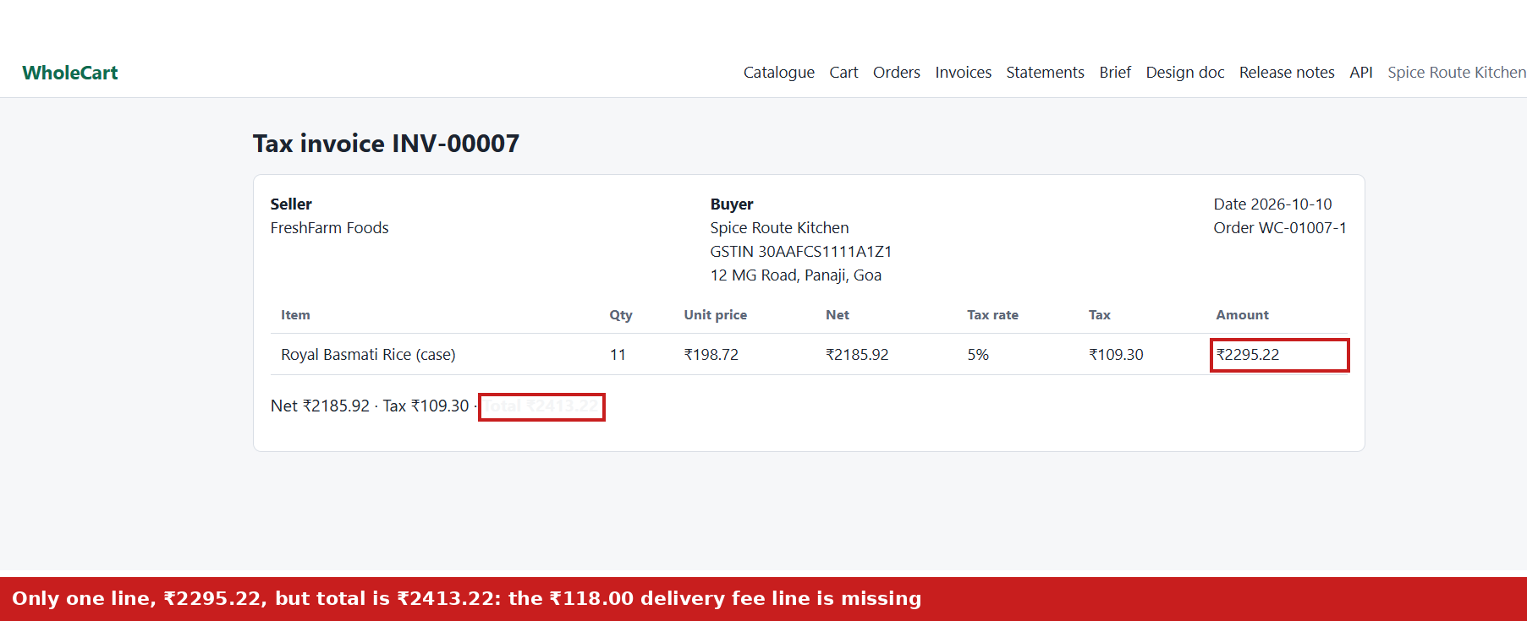
Invoice INV-00007: the single line amount and the total do not match.

DEF-06: Invoice total is almost invisible
Severity: Low
User and page: buyer1, Invoices, INV-00007 (order WC-01007-1)
Steps to reproduce:
- As buyer1, add 11 cases of Royal Basmati Rice (SKU-0011, FreshFarm Foods) and place the order (order WC-01007-1, total ₹2,413.22).
- As seller2, open Orders and click Accept, then Ship, then Deliver.
- As buyer1, open Invoices and open INV-00007.
Expected result: “Total ₹2413.22” is readable and styled like the rest of the text.
Actual result: The total is rendered in a nearly white colour on a white background and can hardly be seen.
Screenshot:
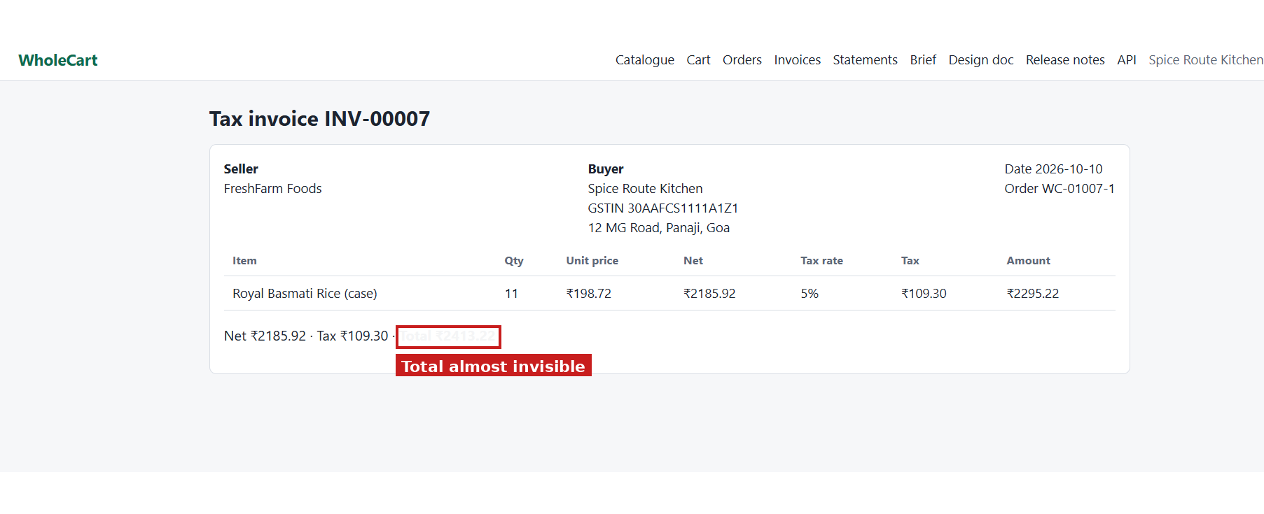
Invoice INV-00007: the red box marks the almost invisible total.

DEF-07: Refund requests exceed the quantity ordered, and both are approved
Severity: High
User and page: buyer1 (order WC-01007-1), then seller2 (Refunds)
Steps to reproduce:
- Use the delivered order WC-01007-1 (11 cases of Royal Basmati Rice, total ₹2,413.22).
- As buyer1, in “Refund or exchange” choose Partial refund, enter 3 and click Send request.
- Enter 9 and click Send request again.
- As seller2, open Refunds and approve both requests.
Expected result: The second request is rejected, because 3 + 9 = 12 cases is more than the 11 ordered. The total quantity refunded on a line can never exceed the quantity ordered (BR-17).
Actual result: Both requests are accepted (₹625.97 and ₹1,877.90, status “requested”) and both are approved. The total approved refund is ₹2,503.87, which is ₹90.65 more than the order total of ₹2,413.22.
Impact: Money is refunded that the buyer never paid.
Screenshot:
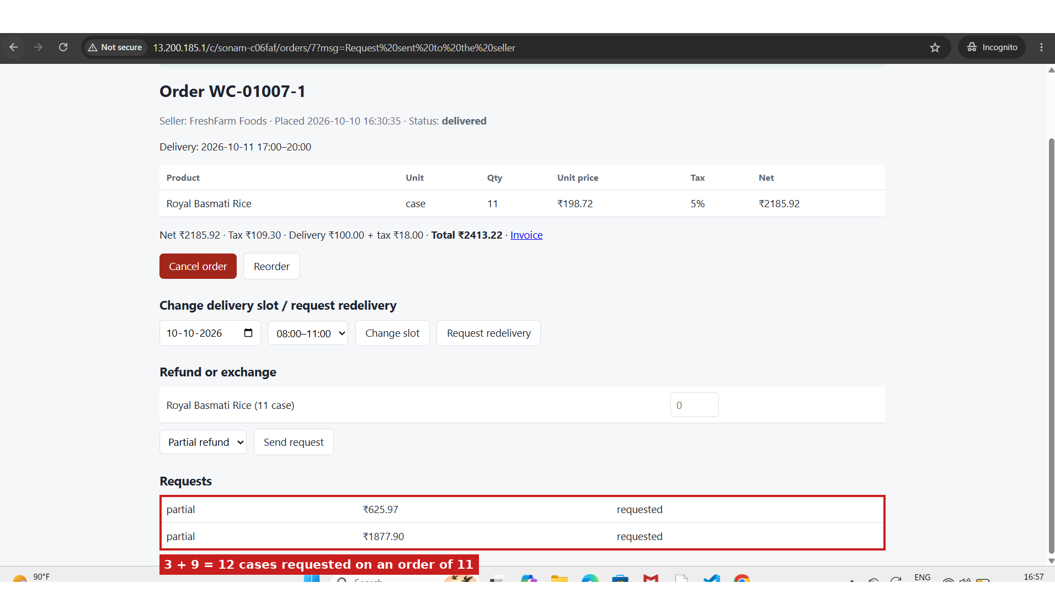
Order WC-01007-1: both refund requests accepted (3 + 9 = 12 cases on an order of 11).
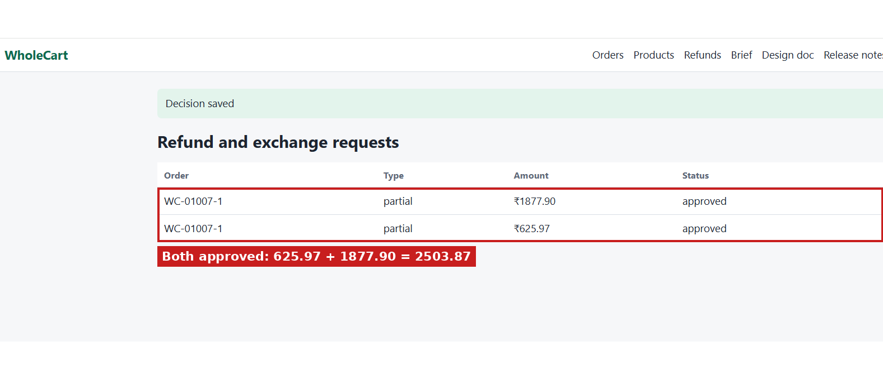
Seller refunds page: both requests approved, total ₹2,503.87.

DEF-08: Monthly statement includes a cancelled order
Severity: High
User and page: buyer1, Statements, October 2026
Steps to reproduce:
- As buyer1, place an order for 1 case of Chef’s Banana Chips (WC-01008-1, ₹2,495.46) and cancel it. Status becomes cancelled.
- Have WC-01007-1 delivered (₹2,413.22) and its refunds approved (see DEF-07).
- Open Statements and choose October 2026.
Expected result: The statement lists delivered orders only, minus approved refunds. Cancelled orders are not included (BR-20).
Actual result: The cancelled order WC-01008-1 is listed and counted. Orders total ₹4,908.68, Refunds ₹2,503.87, Amount due ₹2,404.81.
Impact: The buyer is billed for an order they cancelled.
Screenshot:
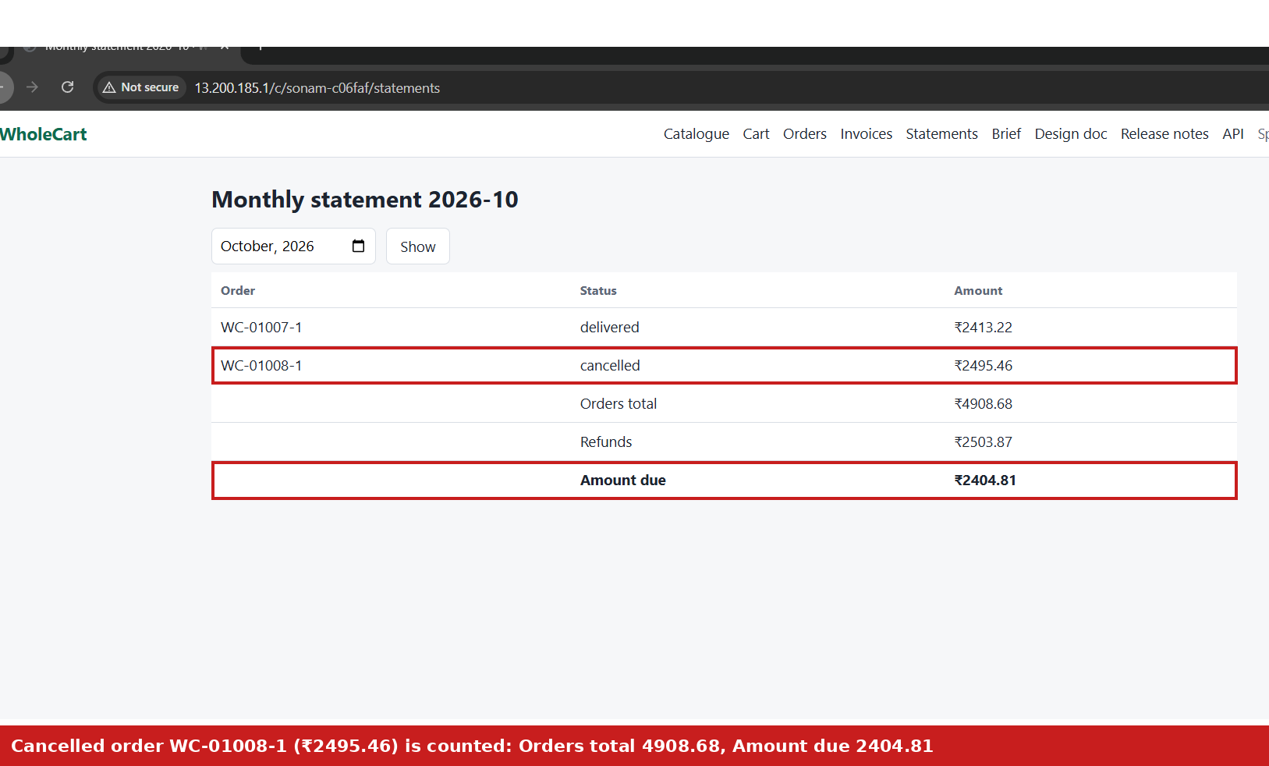
Monthly statement October 2026: the cancelled order is listed and counted.

DEF-09: Minimum order is not enforced for the second seller in a mixed cart (CR-07)
Severity: High
User and page: buyer1, Cart and Checkout
Steps to reproduce:
- Log in as buyer1 and empty the cart.
- Add 11 cases of Royal Basmati Rice (FreshFarm Foods, net ₹2,185.92).
- Add 1 case of Chef’s Basmati Rice (WholeCart Direct, net ₹546.48, below ₹2,000).
- Open Checkout and place the order.
Expected result: Checkout is blocked with “Minimum order value is ₹2000 per seller”, because the minimum applies to each seller separately (CR-07).
Actual result: The order is placed and split into two orders: WC-01009-2 (FreshFarm Foods, ₹2,413.22) and WC-01009-1 (WholeCart Direct, net ₹546.48, total ₹691.80).
Impact: Sellers receive orders below their minimum value. The rule can be bypassed by adding a large order from another seller.
Screenshot:
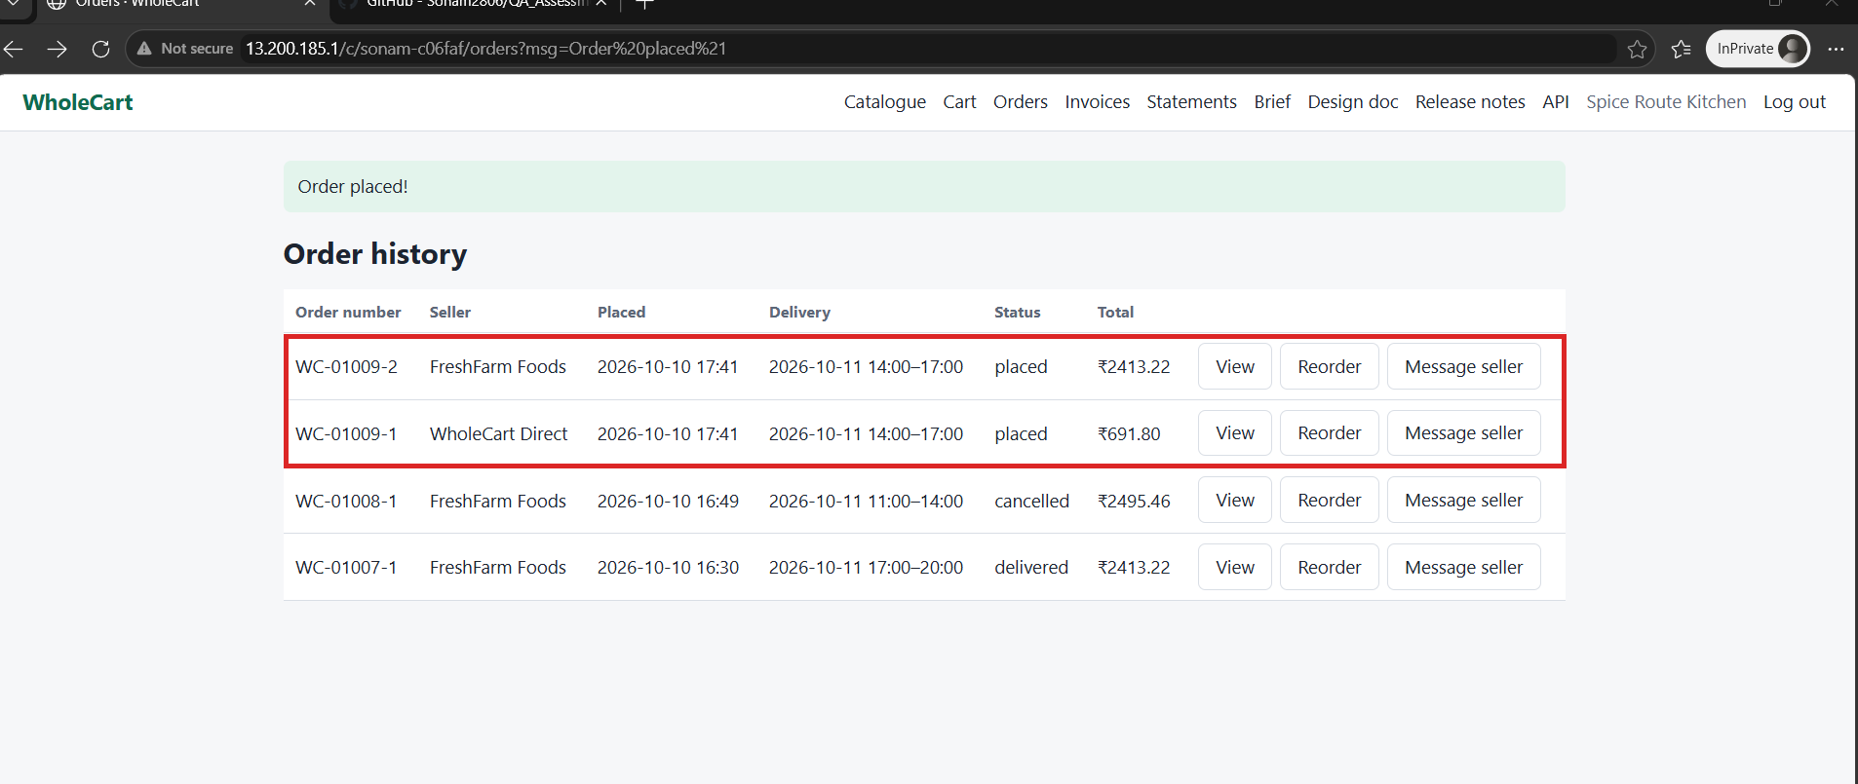
Order history after checkout: WC-01009-1 (WholeCart Direct, ₹691.80) was accepted although its net value is below ₹2,000 (red box marks the two new orders).

DEF-10: Logistics export has no rows although orders are waiting for delivery
Severity: High
User and page: operator, Logistics export (/operator/export)
Steps to reproduce:
- Place orders WC-01009-1 and WC-01009-2 (see DEF-09), both for delivery on 2026-10-11, 14:00–17:00. Status is “placed”.
- As the operator, open Logistics export and click Run export now.
- Open the new run and download the file (logistics.csv).
Expected result: The file has a row for each open order due for delivery, including WC-01009-1 and WC-01009-2, with buyer, address, date, slot and pieces.
Actual result: The run shows 0 rows. The downloaded file contains only the header: order_number, buyer_name, delivery_address, delivery_date, slot_start, slot_end, pieces. All earlier hourly runs (11 to 30) also show 0 rows.
Impact: The logistics partner gets no list of deliveries, so confirmed orders could be missed.
Screenshot:
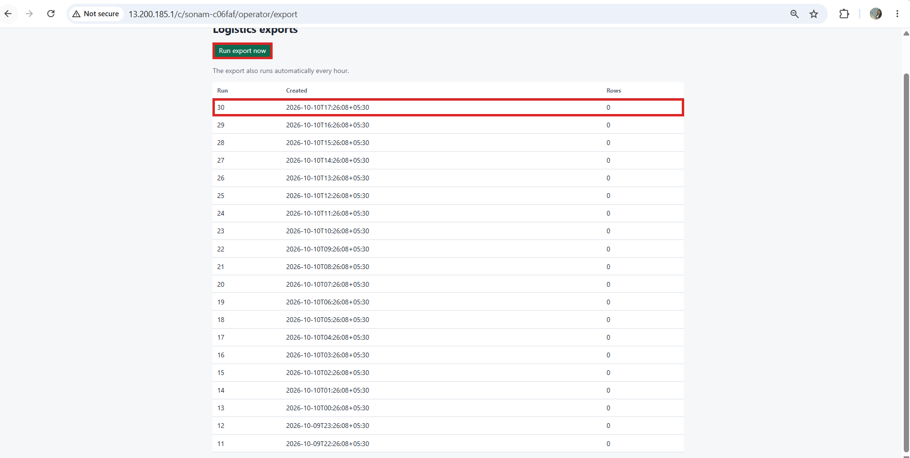
Logistics exports page: every run shows 0 rows (red boxes mark the Run export now button and the latest run).

Checks that passed
- Minimum order: net ₹1,987.20 is blocked with “Minimum order value is ₹2000 per seller”; net ₹2,185.92 is accepted (CR-07). The check uses net value, not the gross amount.
- Tax, delivery fee and order totals on checkout and on the order page are correct (5% tax, ₹100 + 18% delivery fee below ₹3,000 net).
- Buyers cannot open other buyers’ orders through the screens (BR-21), tested between buyer1 and buyer2 in both directions.
- The Hindi (Devanagari) name of buyer3 displays correctly in the seller order list.
- Stock is reduced in pieces when an order is placed.
- Change slot on a delivered order is blocked with “The delivery slot can only be changed before the order ships”.
- Cancel order on a delivered order is blocked.
- All actions on the cancelled order WC-01008-1 (cancel, request redelivery, change slot, refund form) are blocked.
- A morning slot for same-day delivery is refused with “Same-day delivery is only available for afternoon and evening slots”. The operator cut-off setting is 20:00.
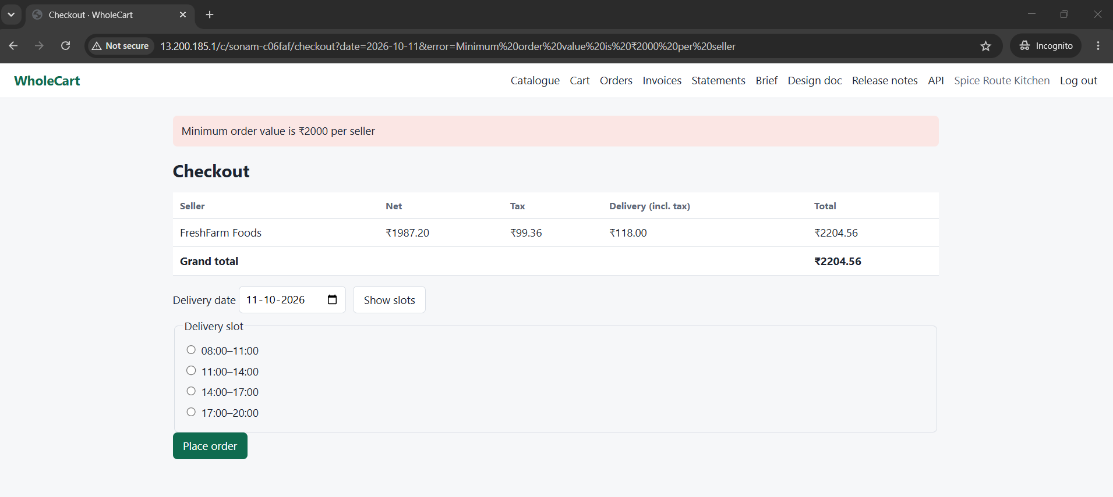
Checkout blocked at net ₹1,987.20 because the minimum is ₹2,000 per seller (pass).
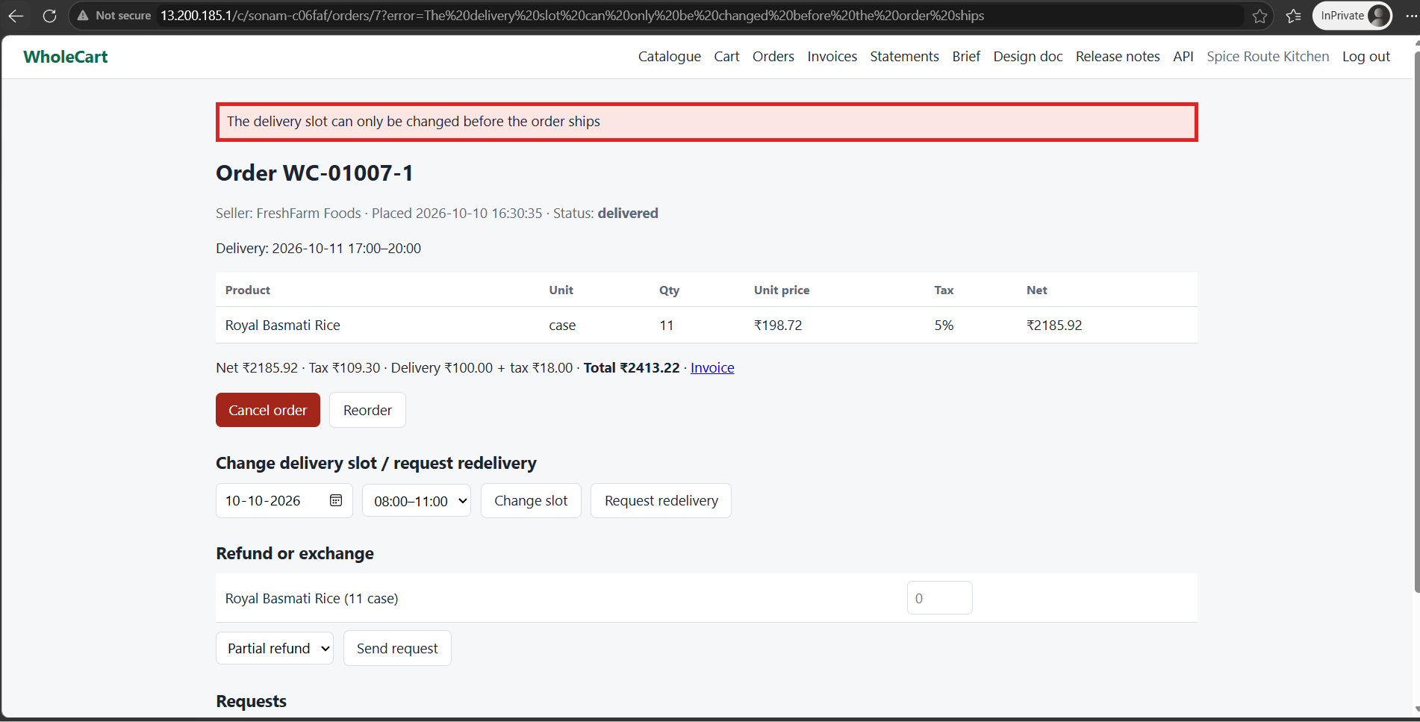
Change slot on delivered order WC-01007-1 is refused (pass).
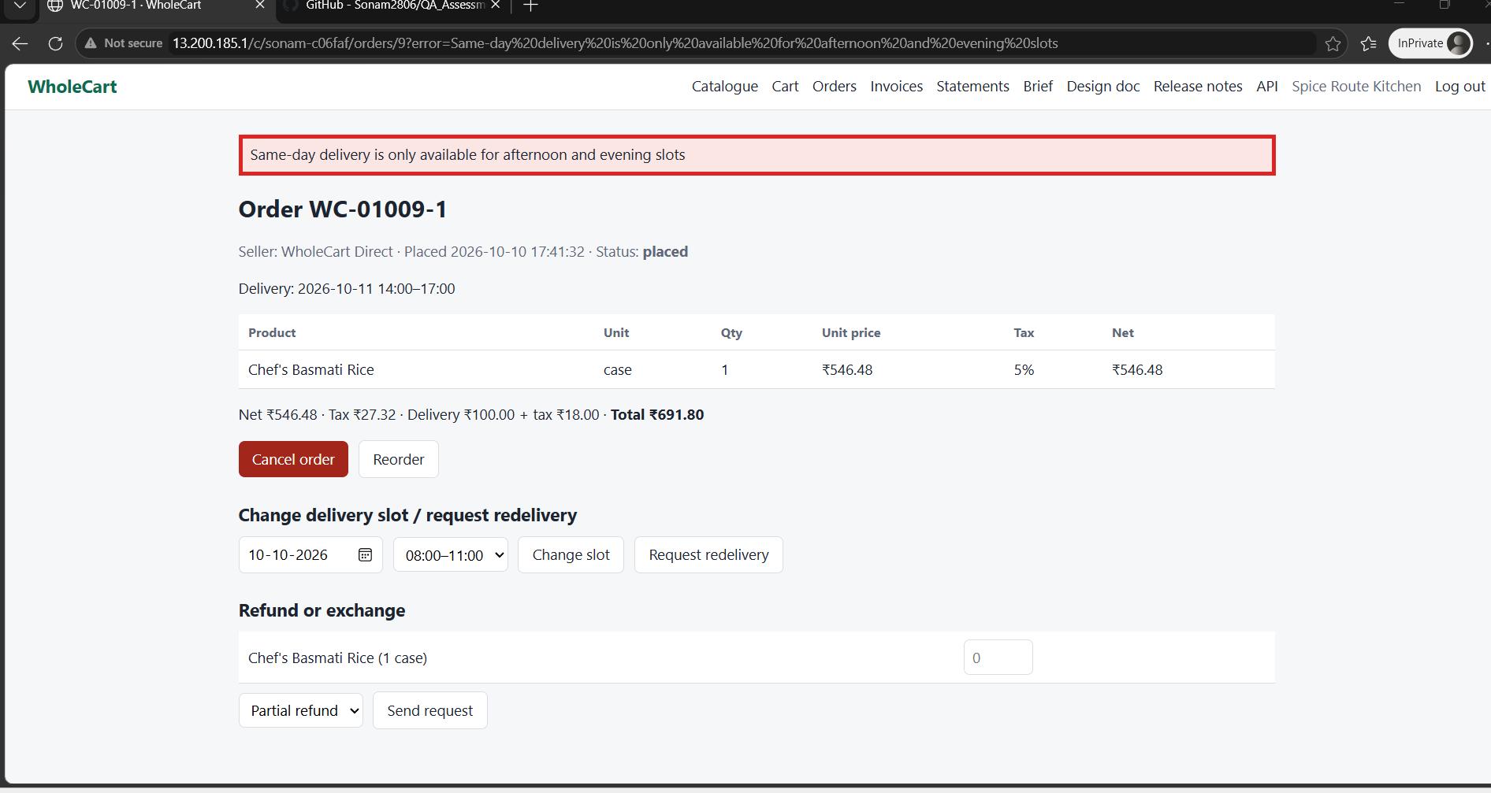
Same-day morning slot is refused with a clear message (pass).

Not yet confirmed
- Same-day cut-off boundary (operator setting is 20:00, BR-06). The evening slot for the same day still shows the “afternoon and evening” error; to be re-tested with the store clock fixed at 09:00.
- Cancellation window (5 minutes in operator settings): Cancel order is still shown on orders placed more than 5 minutes earlier. Not yet clicked.
- Pilot OPS-14 (buyer3, free delivery until 31 Oct 2026), orders per delivery slot, and the exact ₹2,000 and ₹3,000 boundaries.
- Operator settings and store clock (the logistics export is covered in DEF-10).
- API access control for other users’ orders and invoices.

